HANOI UNIVERSITY OF SCIENCE AND TECHNOLOGY
School of Information and communications technology

Software Requirement Specification
Version 1.2

AIMS: An Internet Media Store
Subject: Software Requirement Specification

TEAM-06

Team members | - Đỗ Gia Huy - 20226085  - Nguyễn Trung Hiếu - 20226082  - Nguyễn Minh Quang - 20226123  - Trần Phạm Minh Đức - 20226077

Hanoi, 10, 2025

Table of contents

1 Introduction 2
1.1 Objective 2
1.2 Scope 2
1.3 Glossary 2
1.4 References 3
2 Overall Description 4
2.1 Survey 4
2.2 Overall requirements 5
2.3 Business process 5
2.3.1. Add/Update Product 6
2.3.2. Place Order 7
3 Detailed Requirements 10
3.1 Use case Add/Update Product 10
3.2 Use case Pay Order by VietQR 15
3.3. Use case Pay Order by Credit Card 19
3.4. Use case Place Order 22
3.5. Use case View Product Details 27
4 Supplementary specification 33
4.1 Functionality 33
4.2 Usability 33
4.3 Reliability 34
4.4 Performance 34
4.5 Supportability 35
4.6 Other requirements 35

Introduction

Objective
This SRS states what the AIMS software must do so designers can build and testers can verify it. It specifies externally observable behavior for Customers, Product Managers, and Administrators, plus interactions with external services (payments, email).

Scope
Product name: AIMS — An Internet Media Store.
In scope (high level): browsing/searching products without login; cart management; placing and paying for orders (QR / credit-card); order confirmation/cancellation and email notifications; pending-order processing by Product Managers; product maintenance (add/update/delete) with history and business rules; user/role administration and notification emails.
Out of scope: UI design details (deferred to UI specs/prototypes per slides).

Glossary

No | Term | Explanation | Example | Note
1 | AIMS | The software being specified | — | System under development
2 | Customer | Public user (no login) who browses, carts, and orders | — | No login required.
3 | Product Manager (PM) | Staff who maintains products and processes pending orders | — | Role-based access.
4 | Administrator | Staff who manages users/roles and admin actions | — | Sends admin emails.
5 | VAT | Value-Added Tax applied to product totals/invoice | — | Appears on invoice.
6 | Pending order | Order awaiting PM approval/rejection | — | 30 per page.
7 | CCU | Concurrent users (non-functional throughput metric) | — | Targets below.
8 | VietQR / PayPal Sandbox | Payment services used for QR / credit-card payment and refund flows | QR code and REST APIs | Demo integrations.
9 | API | Applications programming interface - a set of protocols that specifies the way applications communicate with each other | VietQR API

References
- AIMS-ProblemStatement-ver3.0.pdf
- 02-RequirementModelingWithUC.pdf

Overall Description

Survey
List of actors:
- Customer (no login): Public user who browses/searches products, manages a cart, and goes through ordering and payment without authentication. Can pay by default via QR and optionally switch to credit card during checkout.
- Product Manager: Staff user (role-based access) responsible for catalog maintenance (add/update/delete with recorded history and business rules) and for reviewing pending orders to approve or reject.
- Administrator: Staff user (role-based access) who manages users and roles: create/view/update/delete, reset passwords, block/unblock, set roles; the system sends administrative notification emails.
- VietQR (external payment service): Third-party QR payment provider used by AIMS for default checkout: AIMS calls VietQR to generate a QR code, displays it, and verifies the transaction via callbacks/sync. Sandbox/test endpoints and callback specs are provided for integration.
- PayPal (external payment service): Credit-card payment and refund provider used in AIMS for demo purposes: integrates via PayPal REST APIs (Payments/Orders/Capture/Refund); refunds are issued through the API for captured payments.
Key data: products (with type-specific attributes), carts, orders, users/roles, emails, payments, shipping fees.

Overall requirements
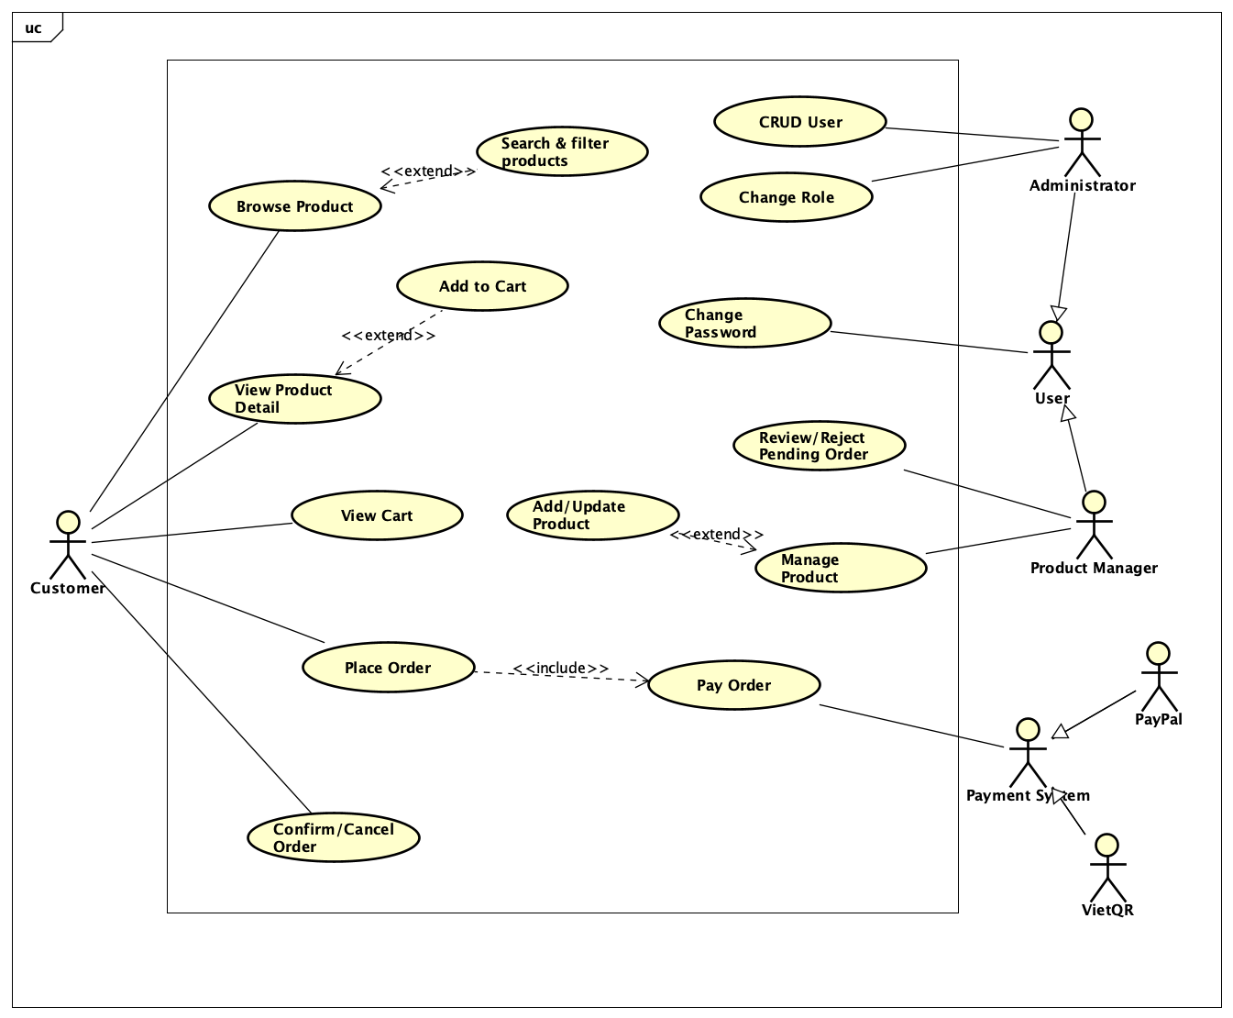

Business process
- Customer can browse a list (20 random products on start), search by title/category, filter by price ranges, and view product details by type.
- Customer can add items to cart, view the cart (totals excl. VAT, itemized details), change quantities/remove items, and be notified of insufficient stock and lacking quantity.
- When placing an order, the system checks stock; collects/validates delivery info; calculates shipping fees (weight/location/rules); shows invoice (incl. VAT & shipping); supports QR or credit-card payment; then confirmation/cancellation with emails and refund; records payment and placed order.
- Product Managers maintain products (add/update/delete) with history and business rules (price in 30–150% of original; notify on invalid input/date). They process pending orders (approve/reject, 30 per page, rejection emails).
- Administrators manage users/roles, block/unblock, reset passwords, and the system sends admin emails; role-based login is required for Admin/PM features.
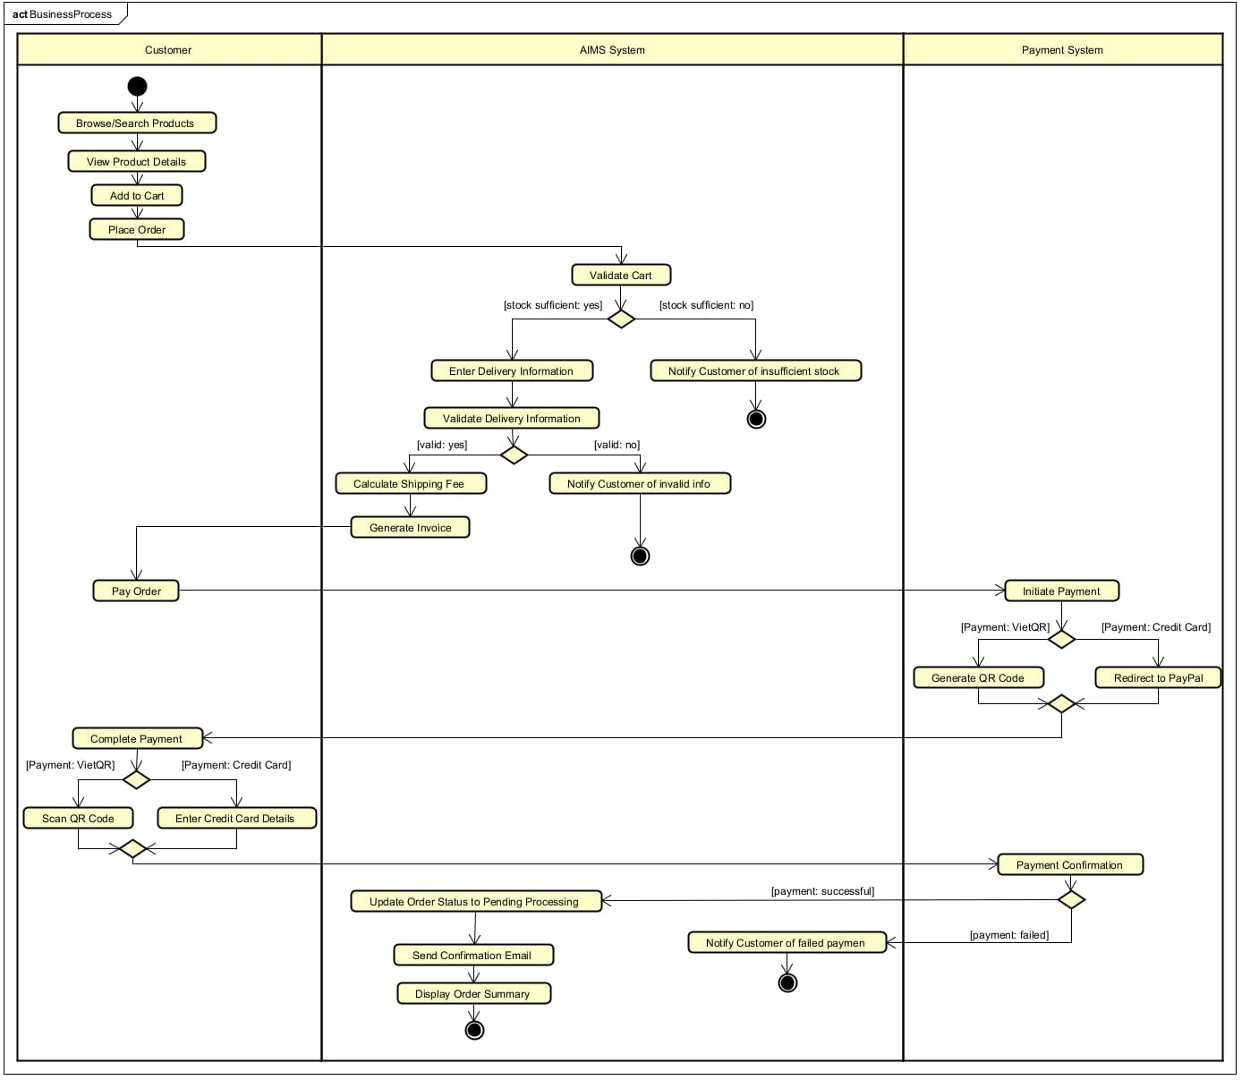

Detailed Requirements

Use case Add/Update Product

Use Case “Add/Update Product (Product Manager)”
1. Use case code
UC001
2. Brief Description
This use case describes the interaction between the Product Manager and the AIMS system when the Product Manager wishes to add a new product or update an existing product.
3. Actors
3.1. Product Manager
4. Preconditions
- The Product Manager is logged in with the appropriate role to access product-maintenance features.
- For Update: the target product already exists in the catalog.
5. Basic Flow of Events (Success)
- Product Manager requests to Add a new product
- Software displays the product form with a product type selector (Book, Newspaper, CD, DVD).
- Product Manager enters product data, including title/category (AIMS supports search by product title or category), original value, current price, and type-specific fields as required.
- Software validates:
  - Price policy: current price is within 30%–150% of the original value.
  - Type-specific required fields are present (per product type list below).
  - Date formats are valid where applicable (e.g., publication date). If invalid, the system notifies the Product Manager.
- Software performs operation Add by creating a new product record.
- Software stores a history entry for the addition or edit.
- Software confirms success and shows the saved product summary.
6. Alternative Flows
Table 2 — Alternative flows of events for UC “Add/Update Product”
No | Location | Condition | Action | Resume location
1 | At Step 1 | User chooses Update operation | Software displays Update form | Step 2
2 | At Step 4 | Price violates the 30%–150% band | Software notifies invalid price; submission rejected | Step 2
3 | At Step 4 | Missing type-specific required info | Software notifies invalid/insufficient info | Step 2
4 | At Step 4 | Invalid date format (e.g., publication date) | Software notifies invalid format | Step 2
5 | At Step 5 | User performs Update operation | Software performs operation Update: applies the submitted changes to the existing record | Step 6
6 | At Step 3 (Update) | Product Manager adjusts stock quantity manually | Software requires reason for stock change and records it | Step 4

7. Input data
Table A — Input data for Add/Update Product
A.1 Common fields (all products)
No | Data fields | Description | Mandatory | Valid condition / Notes
1 | Title | Title of products | Yes | Must be between 3 and 100 characters long; no special characters other than hyphen and apostrophe.
2 | Category / Product type | (Book, Newspaper, CD, DVD) | Yes | One of the supported product types
3 | Original value | Implicitly inferred from the requirements | Yes | > 0; used for price-band validation (see A.6);
4 | Current price | The current price after adjustments from the original price | Yes | Must be within 30%–150% of original value
5 | Stock quantity (if updating quantity) |  | Conditional (Update) | Manual adjustments must record a reason
A.2 Book-specific (required)
No | Data fields | Description | Mandatory | Valid condition | Example
1 | Author(s) | Book authors | Yes | Must be between 1 and 50 characters; can contain letters, spaces, and commas. | “Robert C. Martin”
2 | Cover type | Paperback or hardcover | Yes | One of {Paperback, Hardcover} | Hardcover
3 | Publisher | Publishing house | Yes | Must be between 3 and 100 characters; only alphabetic characters, spaces, and hyphens. | Pearson
4 | Publication date | Date of publication | Yes | Must follow the format dd/mm/yyyy; the date must be a valid date (e.g., 30/12/2018). | 30/12/2018
A.3 Newspaper-specific (required)
No | Data fields | Description | Mandatory | Valid condition | Example
1 | Editor-in-chief | Lead editor | Yes | Must be between 3 and 100 characters long; only alphabetic characters, spaces, and hyphens. | Nguyen Van A
2 | Publisher | Publishing organization | Yes | Must be between 3 and 100 characters; only alphabetic characters, spaces, and hyphens. | Vietnam News Agency
3 | Publication date | Date of issue | Yes | Must follow the format dd/mm/yyyy; the date must be a valid date (e.g., 05/10/2025). | 05/10/2025
4 | Issue number | Issue identifier | No | Must be a positive integer (e.g., 342). | 342
5 | Publication frequency | Daily/Weekly/etc. | No | Must be one of {Daily, Weekly, Monthly}. | Weekly
6 | ISSN | International Standard Serial Number | No | Must be 8 digits, with a hyphen between each 4 digits. | 0868-1234
7 | Language | Publication language | No | Must be a valid language. | Vietnamese
8 | Sections | e.g., politics, business, sports, culture | No | Must be a valid section from section rules. | Politics; Business

A.4 CD-specific (required)
No | Data fields | Description | Mandatory | Valid condition | Example
1 | Artists | Performer(s) | Yes | Must be between 3 and 100 characters long; only alphabetic characters, spaces, and hyphens. | “Adele”
2 | Record label | Label/publisher | Yes | Must be between 3 and 100 characters long; only alphabetic characters, spaces, and hyphens. | XL Recordings
3 | Tracks list | List of tracks | Yes | Each track has title and length | “Track 01 – Hello – 4:55”
4 | Genre | Musical genre | Yes | Must be a valid musical genre from musical genre rules. | Pop
5 | Release date | Date of release | No | Must follow the format dd/mm/yyyy; the date must be a valid date (e.g., 05/10/2025). | 20/11/2015
A.5 DVD-specific (required)
No | Data fields | Description | Mandatory | Valid condition | Example
1 | Disc type | Blu-ray or HD-DVD | Yes | One of {Blu-ray, HD-DVD} | Blu-ray
2 | Director | Film director | Yes | Must be between 3 and 100 characters long; only alphabetic characters, spaces, and hyphens. | Christopher Nolan
3 | Runtime | Total running time | Yes | Positive duration | 152 min
4 | Studio | Production studio | Yes | Must be between 3 and 100 characters long; only alphabetic characters, spaces, and hyphens. | Warner Bros.
5 | Language | Audio language(s) | Yes | Must be a valid language. | English
6 | Subtitles | Subtitle language(s) | Yes | Must be valid languages. | English; Vietnamese
7 | Release date | Date of release | No | Must follow the format dd/mm/yyyy; the date must be a valid date (e.g., 05/10/2025). | 16/07/2010
8 | Genre | Film genre | No | Must be a valid genre from film genre rules. | Action
Validation note: When product data does not comply with rules or date format is incorrect, the software notifies the Product Manager.
8. Output data
Table B — Output data after successful Add/Update
No | Data fields | Description
1 | Product title & type | The saved product and its type (Book/Newspaper/CD/DVD)
2 | Original value & current price | Confirmed values satisfying the 30%–150% band
3 | Type-specific attributes | The saved attributes according to the product type (see A.2–A.5)
4 | History entry recorded | Addition/edit stored in history
9. Postconditions
- Add: A new product exists in the catalog; a history entry is recorded.
- Update: The product reflects submitted changes; a history entry is recorded.
- Saved current price respects the 30%–150% policy; required type-specific attributes are present.

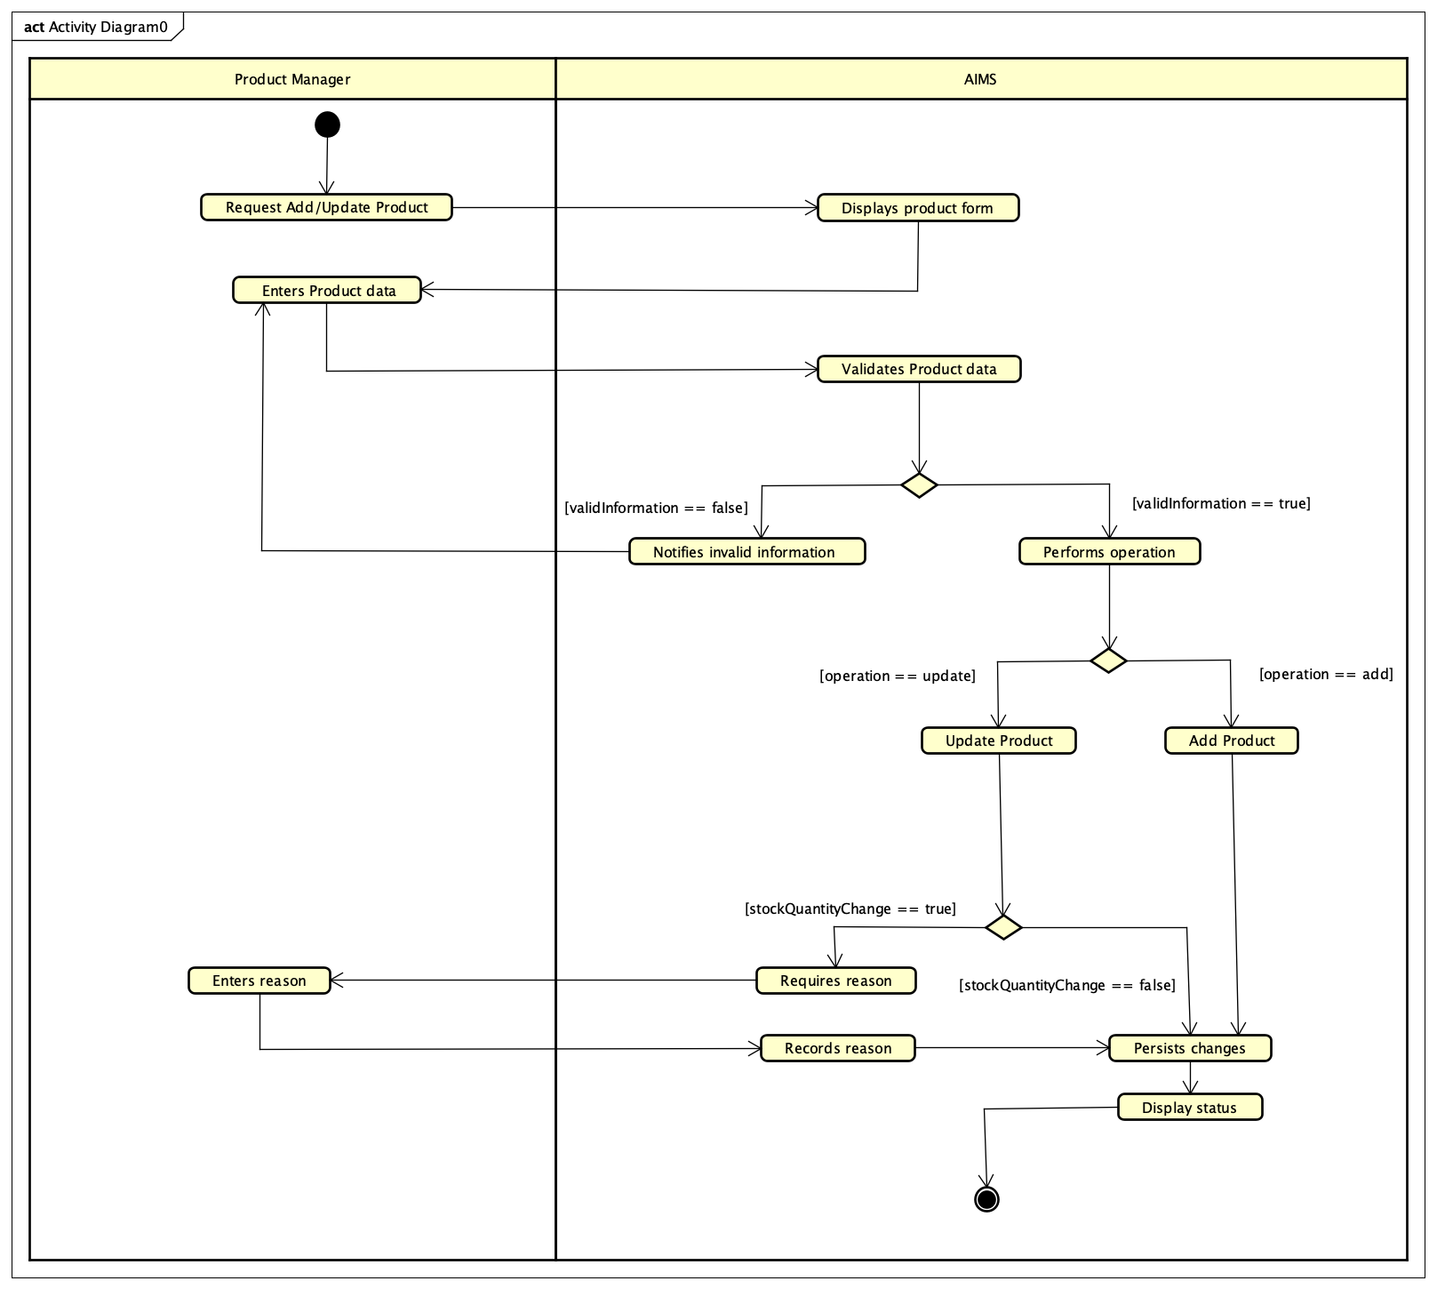

Use case Pay Order by VietQR

Use Case “Pay Order by VietQR”
Use case code
UC004
Brief Description
This use case describes the interaction between the Customer and the AIMS system when the customer wishes to pay for a placed order using a QR code (VietQR).
Actors
3.1. Customer
3.2. VietQR
3.3. AIMS System
Preconditions
1. Customer has successfully placed an order and entered valid delivery information
2. The cart is valid, and stock is sufficient for all selected items.
3. The invoice (product list, VAT, and shipping fees) has been successfully generated
4. The AIMS system is connected to the VietQR sandbox environment.

Basic Flow of Events
- The software sends a request to VietQR to generate a payment QR code, containing order information (order ID, total amount, merchant code, transaction content).
- VietQR generates the QR code and returns the encoded image and transaction reference to AIMS software.
- The software displays the generated QR code on the screen for the Customer to scan.
- The Customer scans the QR code using a banking app and confirms the payment transaction.
- The software verifies the payment transaction status through the VietQR callback or query API.
- The software evaluates the transaction result
- The software updates the order status to Pending Processing, records the transaction, and sends the payment confirmation email to the Customer.
- The software displays a message confirming successful payment and summarizes order and transaction information.
- End of flow
6. Alternative flows
Table N-Alternative flows of events for UC Pay order by QR
No | Location | Condition | Action | Resume location
1 | Step 2 | VietQR API fails to generate QR code. | ▪ Display “Unable to generate QR code.”  ▪ Allow retry or switch to another payment method. | Step 1
2 | Step 4 | Customer cancels or closes the payment app before confirming. | ▪ Display “Payment not completed.”  ▪ Offer retry option. | Step 1
3 | Step 5 | Payment callback not received (timeout or network error). | ▪ Retry verification after a fixed interval.  ▪ If still not confirmed, mark order as “Awaiting Payment.” | Use case ends
4 | Step 6 | Payment verification fails (invalid signature or mismatch). | ▪ Reject transaction and notify customer.  ▪ Mark order as “Payment Failed.” | Use case ends
5 | Step 7 | Inventory update or database error | ▪ Log the error and set order as “Pending Manual Review.” | Use case ends
7. Input data
Table A-Input data of UC004
No | Data fields | Description | Mandatory | Valid condition | Example
1. | Order ID | Unique identifier of the customer’s order | Yes | Alphanumeric | ORD-2025-1008-0012
2. | Total amount | Total payable (subtotal + VAT + shipping) | Yes | ≥ 0 | 215,000 VND
3. | Merchant code | Store identifier for VietQR | Yes | String | AIMS-HUST-001
4. | Transaction content | Description for payment record | Yes | ≤ 255 chars | Payment for Order ORD-2025-1008-0012
5. | Customer info | Customer name, phone, email, address | Yes | Valid format | Nguyen Van A, 0901234567, Hanoi
6. | QR content | Encoded payment string returned from VietQR | Yes | Must follow VietQR format | https://api.vietqr.vn/qr/abc123xyz
Output data
Table B-Output data of UC004
No | Data fields | Description | Display format | Example
1. | QR code image | Image for customer to scan | PNG/Base64
2. | Payment confirmation message | Text showing payment success | Text | “Payment completed successfully via VietQR.”
3. | Transaction details |  | Text / Table | TXN-998877 – 215,000 VND – 2025-10-08 18:36
4. | Order status | Update order state | Text | “Pending Processing”
5. | Confirmation email | Invoice and transaction summary sent to customer | Email (HTML/PDF)

9. Postconditions
- Payment transaction is successfully confirmed through VietQR.
- Order status is updated to Pending Processing.
- Product inventory is decreased according to the order quantity.
- The customer receives an email with the invoice and payment confirmation.
- AIMS stores the transaction record for reconciliation and auditing purposes.
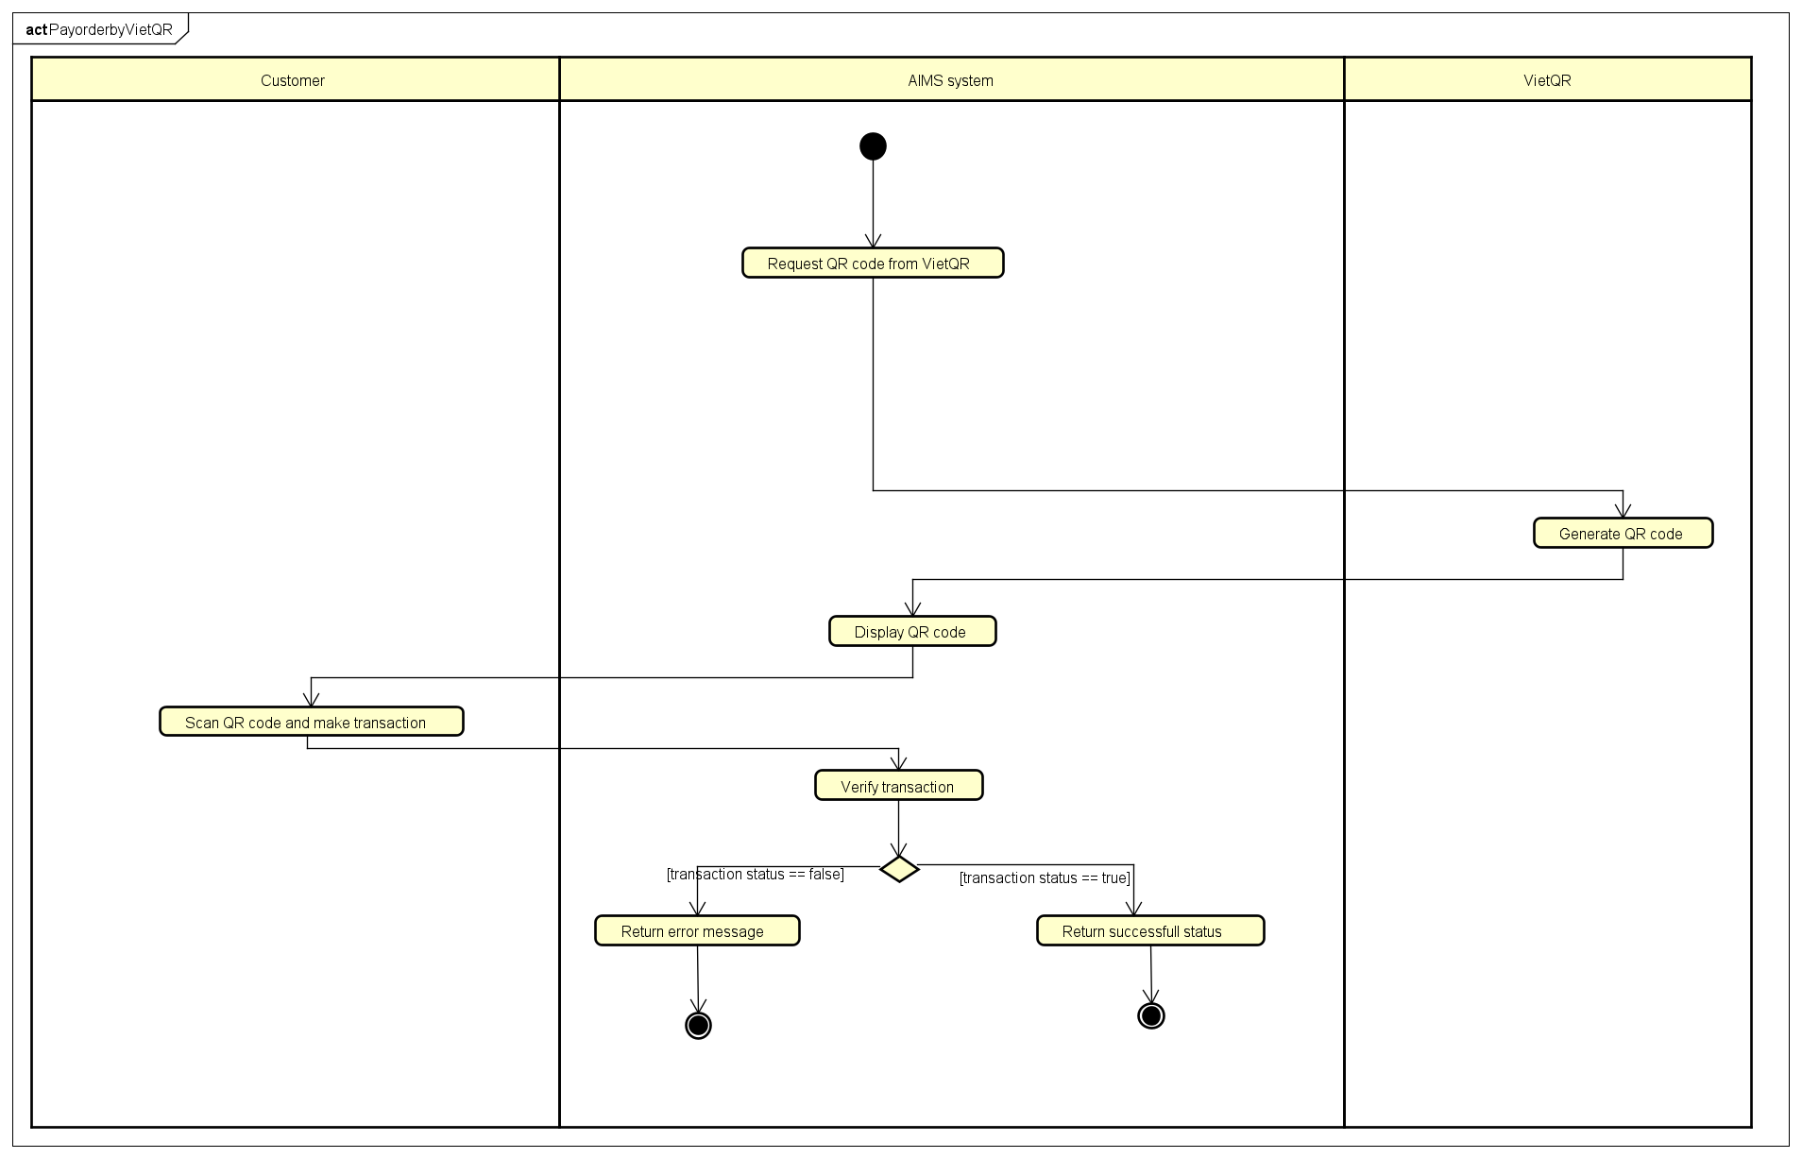

3.3. Use case Pay Order by Credit Card

Use Case “Pay Order by Credit Card”
- Use case code
UC005
- Brief Description
This use case describes how the Customer completes an online payment through PayPal (credit card) in the AIMS system.
- Actors
3.1. Customer
3.2. VietQR
3.3. AIMS System
- Preconditions
1. The customer has completed checkout and is viewing a valid invoice.
2. Stock availability and total payable amount are confirmed.
3. The AIMS system is configured with valid PayPal Client ID/Secret and connected to the PayPal Sandbox API.
4. Network connectivity between AIMS and PayPal is stable.

- Basic Flow of Events
1. The software displays payment options and invoice.
2. The Customer selects Credit Card (PayPal) as the payment method.
3. The software display Paypal checkout form.
4. The Customer fill checkout information.
5. The software validate customer’s checkout information
6. The software compute total fee of the customer’s order
7. The software request PayPal OAuth token from Paypal.
8. Paypal release PayPal OAuth token to the software
9. The software obtains a PayPal OAuth token and creates a PayPal order
10. The software redirects the Customer to PayPal.
11. The Customer logs in or enters card details and approves payment.
12. PayPal verify and redirects the Customer back to AIMS with transaction info.
13. The software verifies and captures the PayPal order.
14. The software stores transaction data, updates stock and order status, and sends a confirmation email.
15. The software displays a message confirming successful payment and summarizes order and transaction information.
16. End of flow.

6. Alternative flows
Table N-Alternative flows of events for UC Pay order by Credit Card
No | Location | Condition | Action | Resume location
1 | Step 5 | Customer’s checkout information is not valid | ▪ Display “Your checkout information is not valid.” | Step 2
2 | Step 9 | PayPal API or token request fails. | ▪ Display “Payment not completed.”  ▪ Offer retry option. | Step 2
3 | Step 13 | Capture not completed or declined. | ▪ Display “Payment unsuccessful.”  ▪ Roll back draft order and release stock. | Step 2
7. Input data
Table A-Input data of UC005
No | Data fields | Description | Mandatory | Valid condition | Example
1. | Order ID | Unique order identifier | Yes | Alphanumeric | ORD-2025-1008-0012
2. | Total amount | Sum of items + VAT + shipping | Yes | ≥ 0 | 215,000 VND
3. | Customer info | Name, phone, email, address | Yes | Valid format | Nguyen Van A, 0901234567, Hanoi
4. | PayPal OAuth Token | Authentication token | Yes | Valid JWT format | A21AAKQ...token
5. | Approval URL | Redirect link returned by PayPal | Yes | HTTPS URL | https://www.sandbox.paypal.com/...
6. | Capture ID | Identifier of successful capture | Yes | Alphanumeric | CAP-9AB23952RC1234567
8. Output data
Table B-Output data of UC005
No | Data fields | Description | Display format | Example
1. | Approval link | Redirect URL for PayPal checkout | Hyperlink
2. | Transaction status | Text showing payment success | Text | “Payment completed successfully via Paypal.”
3. | Transaction info | Capture ID, amount, payer, time | Table | CAP-9AB23952RC1234567 – 325,000 VND – 2025-10-08 18:42
4. | Order status | Update order state | Text | “Pending Processing”
5. | Confirmation email | Invoice and transaction summary sent to customer | Email (HTML/PDF)

9. Postconditions
- The PayPal transaction is successfully captured and recorded.
- Order status is updated to Pending Processing.
- Inventory quantities are adjusted.
- Confirmation email is sent to the customer.
- In case of failure or cancellation, the system releases stock and keeps an audit log.

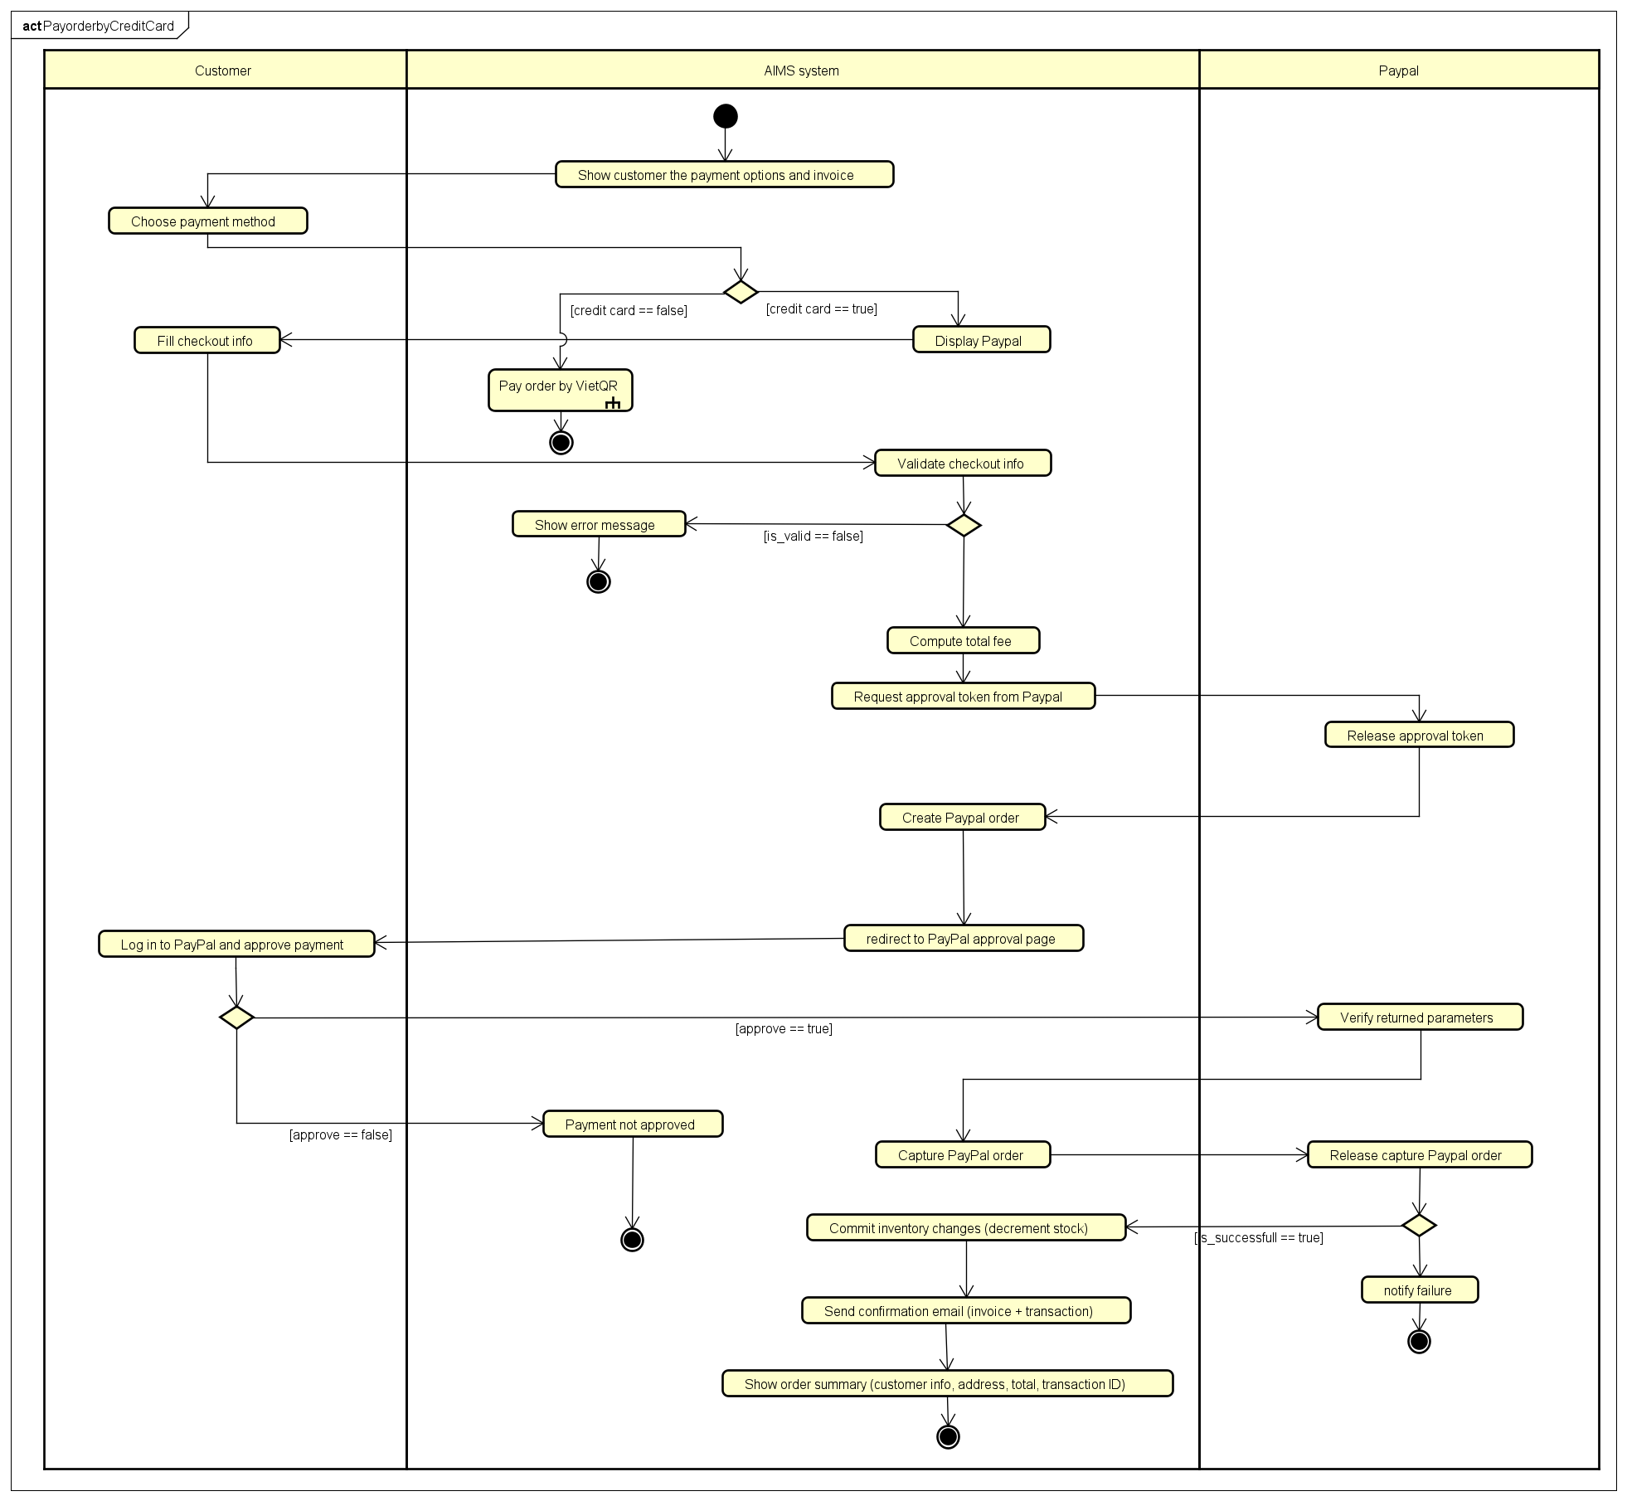

3.4. Use case Place Order

Use Case “Place Order”
1. Use case code
UC002
2. Brief Description
This use case describes how a Customer finalizes the purchase of items in their cart. It covers the entire process from validating the cart, providing shipping information, processing payment, and receiving final confirmation for the order.
3. Actors
3.1.Customer
4. Preconditions
● The Customer's cart contains at least one item.
5. Basic Flow of Events (Success)
- The Customer requests to place an order from the cart screen.
- The System checks if the stock quantity is sufficient for each product in the cart.
- The System displays the delivery information form.
- The Customer enters and submits their delivery information.
- The System validates the delivery information.
- The System calculates the shipping fee based on the total weight and delivery location, applying any applicable promotions
- The System displays the final invoice screen, showing product prices, VAT, shipping fee, and the total amount.
- The System calls the "Pay Order" use case.
- After a successful return from the "Pay Order" use case, the System displays a confirmation screen with order details and transaction information. The screen presents two options: "Confirm Order" and "Cancel Order".
- The Customer reviews the information and selects "Confirm Order".
- The System saves the new order with a "pending" status and records the payment transaction.
- The System sends a detailed order confirmation to the Customer's email.
- The System displays a final "Order Successful" screen.
6. Alternative Flows
Table 1 — Alternative flows of events for UC “Place Order”
No | Location | Condition | Action | Resume location
1 | At Step 2 | The requested quantity for an item exceeds the available stock. | The System notifies the Customer which item is out of stock and displays the available quantity. The System prompts the Customer to update the cart. | Use case ends.
2 | At Step 5 | The delivery information is invalid (e.g., blank required fields, phone number format is incorrect). | The System displays an error message next to the invalid fields and prompts the Customer to correct them. | Step 4
3 | At Step 8 | The "Pay Order" use case returns unsuccessfully (payment failed). | The System displays a "Payment Failed" notification and allows the Customer to try again. | Step 7
4 | At Step 10 | The Customer selects "Cancel Order" on the final confirmation screen. | The System immediately processes a full refund using the original payment method, sends a cancellation confirmation email, and displays a cancellation success message. | Use case ends.

7. Input data
Table 2 — Input data for Delivery Information
No | Data fields | Description | Mandatory | Valid condition | Example
1 | Receiver Name | Full name of the recipient | Yes | Not blank | Nguyen Van A
2 | Phone Number | Contact phone number | Yes | 10 digits, starts with '0', may contain '.', '-', ' ' | 0987-654-321
3 | Province/City | Delivery location | Yes | Selected from a predefined list | Hanoi
4 | Address | Street address details | Yes | Not blank | 1 Dai Co Viet, Hai Ba Trung District
5 | Shipping Instructions | Special notes for delivery | No | - | Please call before delivery.

8. Output data
Table 3 — Output data for Invoice Screen Data

No | Data fields | Description | Display format | Example
1 | Product Title | Title of a media product | - | AIMS DVD
2 | Price | Price per unit (including VAT) | Comma separator, VND | 110,000 VND
3 | Quantity | Quantity of the item | Integer | 2
4 | Amount | Total price for the item | Comma separator, VND | 220,000 VND
5 | Subtotal | Total amount for all products | Comma separator, VND | 450,000 VND
6 | Shipping Fee | Calculated delivery fee | Comma separator, VND | 22,000 VND
7 | Total | Final amount to be paid | Comma separator, VND | 472,000 VND

Table 4: Successful Order Screen Data

No | Data fields | Description
1 | Customer Name | Name of the person who ordered
2 | Phone Number | Contact phone number
3 | Shipping Address | Full delivery address
4 | Total Amount | Total amount paid
5 | Transaction ID | Unique ID from the payment gateway
6 | Transaction Content | Brief description for the payment
7 | Transaction Date | Datetime of the transaction

9. Postconditions
● On successful completion: A new order is created in the system with a "pending" status. A payment transaction is recorded. A confirmation email is sent to the Customer.
● On cancellation or failure: No order is created in the system. If payment was processed and then cancelled, a refund transaction is initiated.

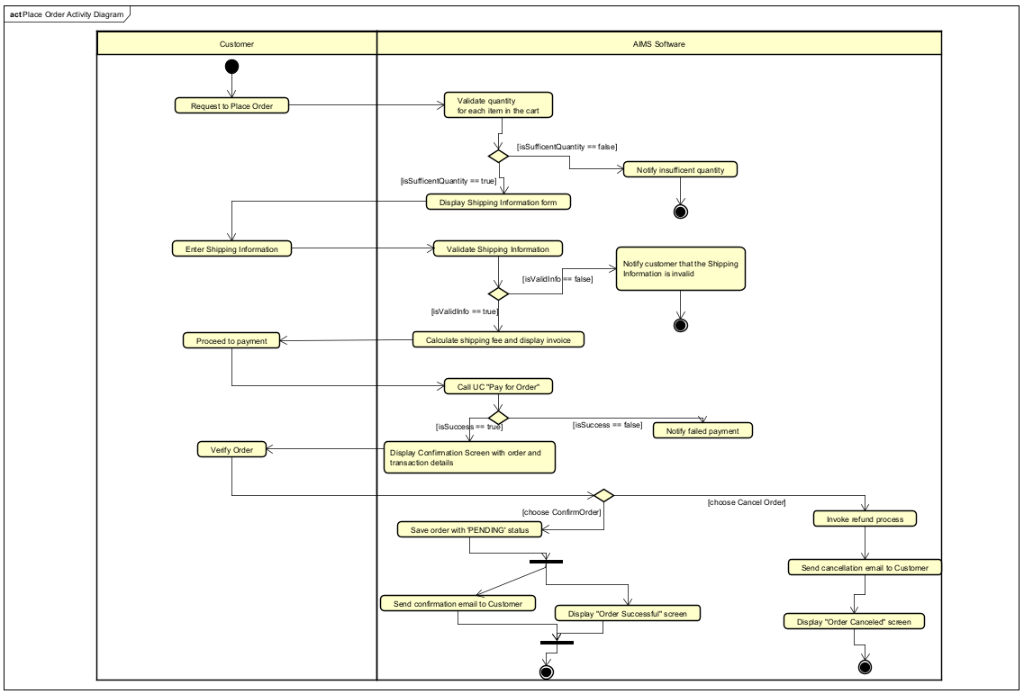

3.5. Use case View Product Details
Use Case “View Product Details”
1. Use case code
UC003
2. Brief Description
This use case describes the interaction between Customer and AIMS when the customer wants to view the detailed information of a selected product (Book / CD / DVD / Newspaper) and may choose a quantity and add the product to the cart.
3. Actors
Customer
4. Preconditions
The customer has navigated to the product list/search results and selected a product. No login is required.
5. Basic Flow of Events (Narrative)
- The customer selects a product from the list/search results to view its details.
- The system checks whether the selected product exists and is available to be shown.
- If the product exists, the system determines the product type.
- Based on the identified type, the system retrieves the type-specific details together with the common information of the product.
- The system displays the detailed information of the selected product.
- The customer reviews the details and selects a corresponding quantity.
- If the selected quantity is zero, the use case ends.
- If the selected quantity is greater than zero, the customer chooses Add to Cart and confirms the action.
- When confirmed, the system adds the product to the cart with the selected quantity and the use case ends.
- If the customer cancels the add action, the use case ends with no change to the cart.
- If, at Step 2, the product does not exist, the system shows “Product not Found” and the use case ends.
6. Alternative Flows
Table 1 — Alternative flows of events for UC “View Detail Product”
No | Location | Condition | Action | Resume location
1 | At Step 2 | productId not found | Software shows “Product not found” | End
2 | At Step 6 | Selected quantity equals 0 | No item is added to cart | End
3 | At Step 8 | Customer cancels the add-to-cart action | No item is added to cart | End

7. Input data
None
8. Output data
Table A – Common information of selectied product
No | Data fields | Description | Display Format | Example
1 | Title | Name of product | String | Introduction to Artificial Intelligence
2 | Price | Price of product | Non-negative integer | 150000
3 | Category | Category of product | String | book
4 | Avail | Number of products available in store | Non-negative integer | 12
5 | Image | Image of product | Image (.png / .jpg) | book.png

Table B – Information of Book
No | Data fields | Description | Display Format | Example
1 | Author | Author of the book | String | Andrew Ng
2 | Publisher | Publisher of the book | String | MIT Press
3 | Cover Type | Type of the cover | String | HardCover
4 | Number of Page | Number of pages | Positive integer | 420
5 | Publication Date | Date when the book is published | Date | 2025-02-27
6 | Language | Language of book content | String | English
7 | Genre | Genre type of book | String | Computer Science

Table C – Information of DVDs
No | Data fields | Description | Display Format | Example
1 | Disc Type | Type of DVD | String | Blu-Ray
2 | Director | Director of the movie | String | Christopher Nolan
3 | Studio | Studio producing the movie | String | Warner Bross
4 | Language | Primary spoken language in the movie | String | English
5 | Subtitle | Available subtitle languages | String | Vietnamese, Japanese
6 | Release Date | Date when the DVD was released | Date | 2024-10-20
7 | Genre | Genre of the movie | String | Science Fiction

Table D – Information of CDs
No | Data fields | Description | Display Format | Example
1 | Artist | Name of artist or band | String | Taylor Swift”
2 | Record Label | Music record label | String | Republic Record
3 | Genre | Music genre | String | Pop
4 | Release Date | Date when the album was released | Date | 2022-11-18
5 | Track list | List of songs in the CD (each includes title and duration) | String | 1. Lavender Haze – 3:22; 2. Anti-Hero – 3:20; 3. Karma – 3:25

Table E – Information of Newspapers
No | Data fields | Description | Display Format | Example
1 | Editor-in-chief | Chief editor responsible for publication | String | Pham Thanh Tung
2 | Publisher | Publisher or press agency | String | Vietnam News Agency
3 | Publication Date | Date of publication | Date | 2025-03-05
4 | Issue Number | Newspaper issue number | Non-negative integer | 315
5 | Publication Frequency | Frequency of release | String | Daily
6 | ISSN | International Standard Serial Number | String | 2616-0455
7 | Language | Publication language | String | Vietnamese
8 | Sections | Newspaper sections | String | Politics; Business; Technology; Culture; Sports

9. Postconditions
- The system has displayed the detailed information of the selected product.
- If the customer confirmed adding with a positive quantity, the product has been added to the cart with that quantity; otherwise, the cart remained unchanged.

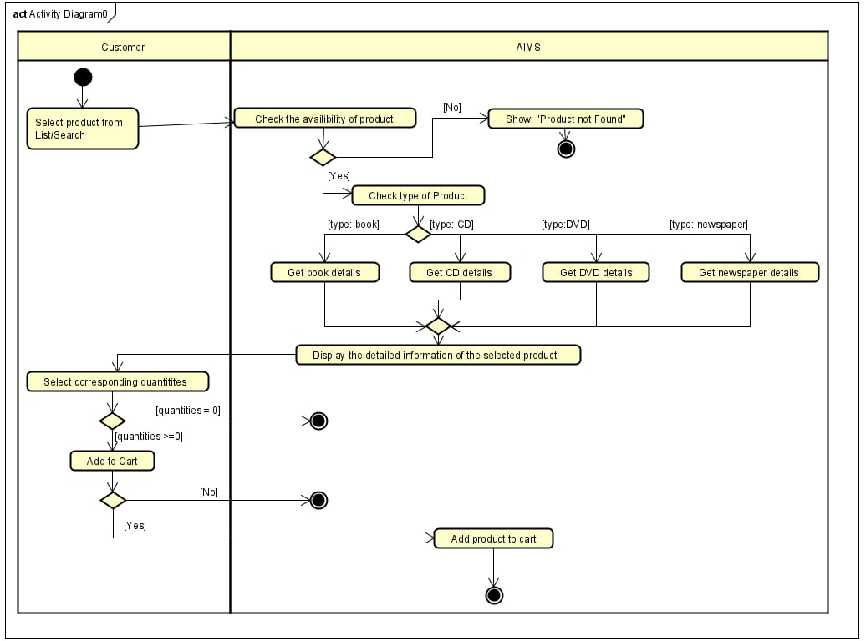

Supplementary specification

Functionality
- Authentication: Distinguish public access (Customer, no login) from authenticated access (staff accounts).
- Authorization (RBAC): Role-based access control for Administrator/Product Manager features; least-privilege by default.
- Validation: Consistent data/business-rule checks at system boundaries (e.g., required fields, price bands, dates).
- Error Handling & User Feedback: Uniform error taxonomy, safe messages, and recoverable flows (retry, correct-and-resubmit).
- Auditing & Logging: Structured logs for actions/events and an audit trail for catalog changes and order lifecycle.
- Transactions & Consistency: Atomic operations for multi-step updates (e.g., order/payment/state changes); rollback on failure.
- Idempotency & Concurrency: Idempotent endpoints for retried requests (e.g., payments); protect against concurrent edits.
- Security (Data Protection): Secure handling of credentials/tokens, transport encryption, safe storage of sensitive fields.
- Notifications: Cross-cutting email (and future channels) for key events (order placed/cancelled, admin actions).

Usability
- Task continuity during ordering: Users can return to any step or exit the flow while ordering; the system preserves state as specified.
- Clear validation & feedback: When inputs violate rules or formats, the system notifies the user performing the action (e.g., PM during product maintenance; customer during cart/order).
- Readable monetary presentation: Amounts shown on invoices and carts use thousand separators, positive integer display, and right alignment; totals show excl./incl. VAT and shipping as specified.
- Discoverability: Product discovery supports browsing/search (title/category) and price filters; details are shown by type (supports learnability without training).
AIMS-ProblemStatement-ver3.0
- Documentation tone: Per slides, keep requirements UI-agnostic in this SRS; UI specifics appear only when necessary to understand behavior.

Reliability
- Availability: The system operates for ≥ 300 hours without failure (High availability).
- Fault recovery: On failure, maximum recovery time ≤ 1 hour.
- Load tolerance: Handles 1,000 concurrent users without breaching performance targets.
- Data integrity: Operations that change state (orders, payments, product edits) are atomic; partial failures result in rollback to a consistent state.

Performance
- End-to-end latency: Typical responses ≈ 2 seconds; at peak load, ≤ 5 seconds.
- Throughput at scale: With 1,000 CCUs, the system continues to meet the above response targets.
- Ordering flow responsiveness:
  - Stock checks on “place order” requests complete before advancing the flow.
  - Shipping fee calculation/recalculation occurs whenever address changes; invoices update accordingly.
  - Pagination for staff workflows: Pending orders: 30 per page, ensuring predictable render time under normal load.

Supportability
- Extensible payments: Integrations with VietQR (QR) and PayPal Sandbox (credit card) are modular to allow future methods without core changes.
- Extensible notifications: Email is required now; SMS/push may be added later without altering business logic.
- Role and user lifecycle: Admin features (create/update/delete users, reset passwords, block/unblock, assign roles) support routine maintenance and onboarding.
- Specification hygiene: Non-functional requirements (this section) capture cross-cutting behavior not tied to a single use case, per slides’ Supplementary Spec guidance.

Other requirements
- Security & access control:
  - No login for customers; login required for Product Managers and Administrators.
  - Role-based authorization: roles can be multiple per user; restrict staff features accordingly.
- Auditability: The system stores a history of product additions/edits/deletions; staff actions that change order state are logged.
AIMS-ProblemStatement-ver3.0
- Regulatory/formatting: Shipping fees not subject to tax; invoices show excl./incl. VAT totals clearly.
- Error handling: For insufficient stock or invalid inputs, the system notifies users and supports correction/resubmission (customer can retry order; PM can correct product data).

